Summary Report: Dissemination Event of The Landscape Analysis of the Uganda Innovation Ecosystem and SMILE Launch
Organized by the Response Innovation Lab in Uganda (U-RIL) in partnership with Startup Uganda
Location: Golden Tulip Hotel |Date: Friday, 29 September 2023 |Time: 8.30am to 1pm
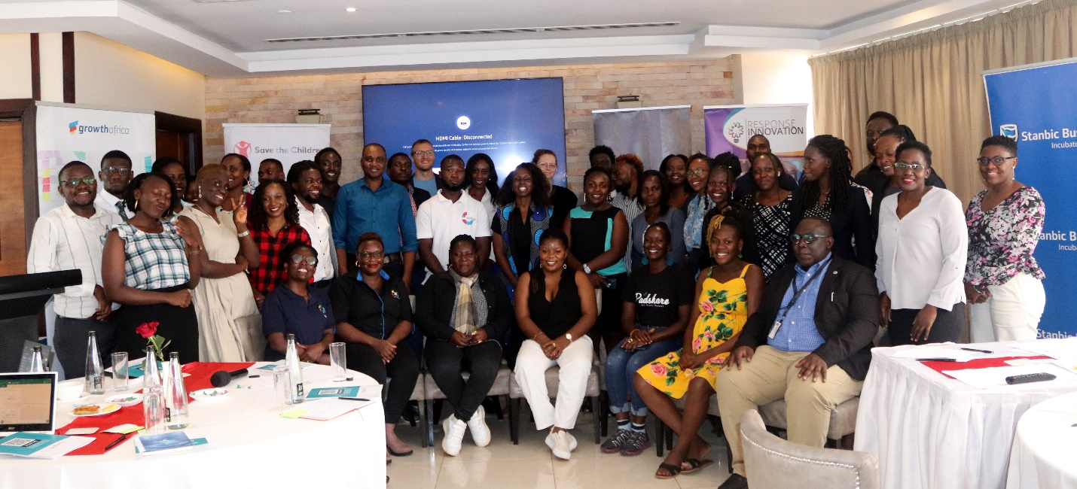
Participants at the Landscape Analysis Dissemination and SMILE Launch Event. September 2023. © I-Venture
Background
On Friday, 29 September 2023, Uganda's Response Innovation Lab (U-RIL), in partnership with Startup Uganda, hosted an event to disseminate the findings of the Landscape Analysis of the Uganda Innovation Ecosystem and to launch SMILE, an interactive ecosystem map. The landscape analysis was commissioned by U-RIL (hosted by Save the Children) through Startup Uganda. It aimed to provide insights into the structure and collaboration opportunities among Uganda's Entrepreneurial Support Organizations (ESOs), including hubs, investment organizations, and support providers. U-RIL also launched SMILE, an interactive ecosystem map, to facilitate partnerships among organizations and individuals within the ecosystem.

Welcoming, opening and introductory remarks
Grace Nakibaala, U-RIL’s Program Manager welcomed participants and highlighted the importance of collaboration, especially with government entities, to guide future actions within the innovation ecosystem.
Jean Makki, Vice Chair of Startup Uganda, delivered the opening remarks and acknowledged that the Uganda innovation ecosystem landscape analysis represented a significant step toward fostering collaboration and generating valuable self-curated data.
Grace Nakibaala described RIL’s role as a center for collaboration, localization, and solving challenges in the humanitarian sector. Max Vieille, RIL’s Global Director, shared RIL's history as a bridge between the bureaucracies in the humanitarian world and the fast-moving innovations and organizations in the humanitarian space.
Presentation of key findings from the Uganda innovation ecosystem landscape analysis
Matthias Möbius, Co-Founder of StartHub Africa, presented key findings from the landscape analysis.
Key findings from ESO analysis
The analysis made nine key findings about ESOs in Uganda. Möbius highlighted three during the dissemination event:
- The need for ESO specialization.
- The need for entrepreneur-centric approaches.
- The need for in-house expertise.
Key Findings from Entrepreneur Analysis
Entrepreneurs emphasized the role of hubs in their success, the need for accessible support, the lack of clarity in offerings, varying levels of trust in hubs, and the shortage of knowledgeable hub contacts.
Feedback on the dissemination of the Uganda ecosystem landscape analysis findings
- Peter Muramira from Uganda Investment Authority highlighted collaboration opportunities between the government and the innovation ecosystem.
- Geofrey Mutabazi, founder of Karaa, pointed out the trickling funding allocation issues from ESOs and entrepreneurs and the talent gap in the startup workforce.
- Kenneth Twesigye, Lead at Tech Buzz Hub, inquired about the status of businesses not using innovation hubs. Möbius responded that entrepreneurs working without innovation hub support were excluded from the ecosystem landscape analysis.
- Merab Twinomugisha from Finding XY enquired about entrepreneur willingness to pay for capacity building. Möbius responded that low cashflows might not allow for it.
- Allan Ananura from I-Venture Startup urged recognition of ESO progress within a short period considering their nascence.
Recommendations from the innovation ecosystem landscape analysis
Recommendations for ESOs included establishing ecosystem-wide definitions, ESOs investing in startups, and including startups in the design stage. Recommendations for funders included balancing quantity and quality, supporting specialized ESO business models, and implementing matching grant programs for ESO investment in startups.
SMILE launch and feedback
Max Vieille from RIL introduced SMILE as an interactive ecosystem map designed to connect innovators and organizations within the humanitarian and social impact sectors. Participants gave feedback on SMILE's features and suggested improvements. Recommendations included improving user-friendliness, stakeholder sensitization for greater adoption, data vetting through structured entry, and recognizing existing work to prevent duplication and ecosystem fragmentation.
Feedback on the landscape analysis
Feedback on the landscape analysis included recommendations to disseminate the report widely among diverse ecosystem stakeholders, encompassing other local actors outside the ESO ecosystem and conducting a study on intellectual property, which is crucial to sustainable entrepreneurship. Suggestions also emphasized involving startups in program design, clarifying ESO terminology, defining startup stages, fostering collaboration, and engaging with the government for policy influence.

The event provided a solid platform for fostering connections and collaboration among stakeholders in the innovation ecosystem in Uganda.

