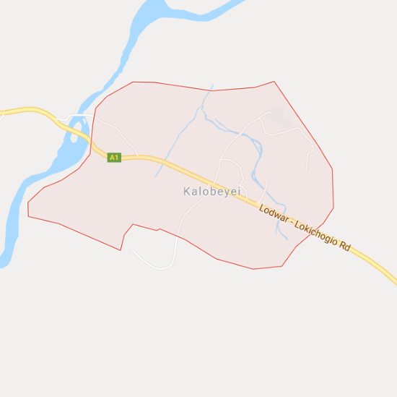
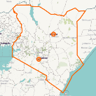
Kalobeyei Settlement
Kalobeyei is located in Turkana County, northwestern Kenya
Established in 2015, Kalobeyei is a planned refugee settlement in Turkana County, designed to promote self-reliance among the refugee community, and greater integration with its host community.

Kalobeyei currently hosts a population of just over 38,000 refugees. [1] The settlement is organized into three “villages”, which are in turn divided into neighborhoods and compounds. Specific sections of the community are designated for businesses. [2] Neighboring Kalobeyei town, the host community, has a population of around 8,000. [3]

This market profile seeks to inform businesses and entrepreneurs of the opportunities and challenges of operating in Turkana County. The references cited here can serve as resources for further market analysis.

Livelihoods

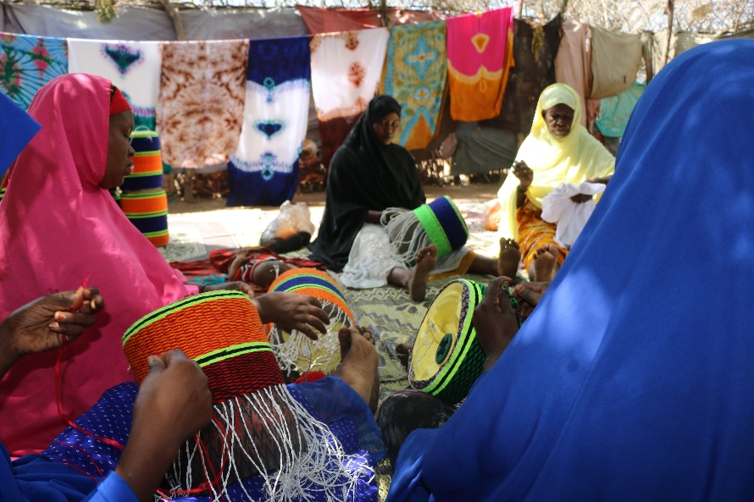  Photo caption (credit:) | Business activity  - Village 1 alone has over 50 retail shops and over 20 restaurants, as well as beauty salons, bars, and tailors. It also has at least one M-PESA outlet and one grain mill. [5]  - Kalobeyei town has more than 30 retail shops, over 10 restaurants or bars, an internet café, a cinema, and a number of commercial services such as tailors and barbers. The Township also counts 5 fueling stations, and agricultural facilities including a slaughterhouse and three grain mills. [3]
Access to finance
- Lack of access to loans or capital was cited as the number one barrier to the development of business. [2]
- Only 10% of businesses used a loan as their startup capital, more than 40% relied on personal savings, while around 30% had no startup capital at all. [2]
- A newly established Turkana West Integrated Savings and Credit Co-operative society is expected to increase access to loans. [4]

Income
Refugee incomes
- The median monthly income for a refugee in Kalobeyei is around KES 3,900. Half of the population earns between KES 900 – 6,500 each month. [2]
- Food assistance in Kalobeyei is distributed via the WFP’s Bamba Chakula platform, with each person receiving KES 1,400 in credit each month. [2]

Monthly incomes in Kalobeyei settlement and town (KES)
A separate survey of Kalobeyei Village 1 and Kalobeyei town groups households and businesses into income segments. This survey found that incomes are effected by agricultural seasonality, with average refugee household incomes fluctuating between KES 6,500 per month in the low season, to KES 8,800 per month in the high season. [4]

Agriculture [2]
- Each household is allocated 675 m² of garden space.
- Around 26% of refugees are involved in agriculture, of which 84% used their produce entirely for self-consumption.
- Lack of access to water and seed inputs were cited as the main barriers to agricultural activity.

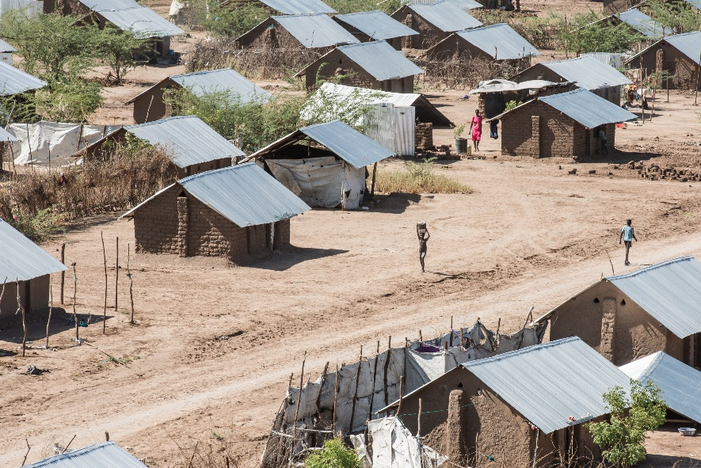  Photo caption (credit:) | Narrative

Education and Skills
Indicators of educational attainment and agricultural skills, disaggregated by country of origin. [2]

Energy
Electricity sources [2]
- Solar panel ownership is as high as 20% among the more established sections of the population.
- Electricity access is less than 4% in Villages 1 & 3, while Village 2 has no access to electricity.
- Privately run diesel mini-grids established by community members serve as many as 100 customers. These operations, however, are typically not profitable, and provide only intermittent power.

Monthly household and business energy expenses in Kalobeyei settlement and town (KES) [5]
Energy expenses

Internet and Mobile
Technology in use  Communications technology used in refugee households (approximate). [2] | NGO connectivity [6]  Perceived quality  - NGOs report quality as decent  NGO access modes  - Microwave link (Safaricom)  NGO access costs  - ~$75/Mbps/month.

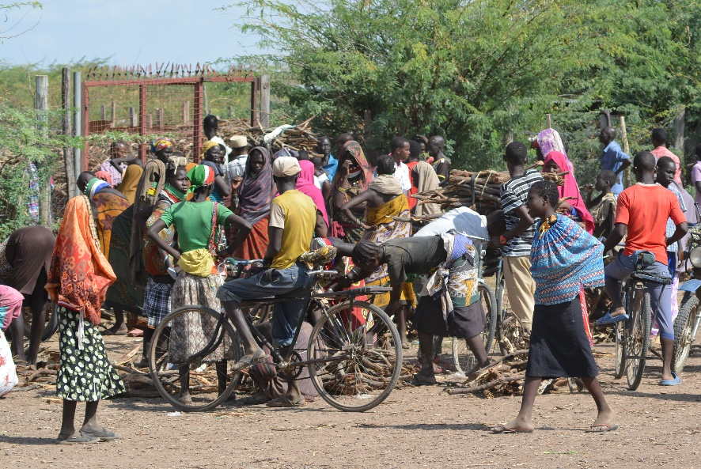  Photo caption (credit:) | Narrative

References

[1] | UNHCR, "Kalobeyei Settlement Population Statistics," 2018.
[2] | University of Oxford, "Self-Reliance in Kalobeyei?," 2018.
[3] | GIZ, "Kalobeyei Resident Town Mini-grid Prefeasibility Study Report," 2018.
[4] | UNHCR, "Kakuma Camp & Kalobeyei Settlement, Kenya - April 2018," 2018.
[5] | GIZ, "Kalobeyei Settlement (Village 1) Solar Hybrid Mini-Grid Prefeasibility Study Report," 2018.
[6] | NetHope.
[7] | USAID, "DHS Survey," 2014. [Online]. Available: https://www.statcompiler.com/.

