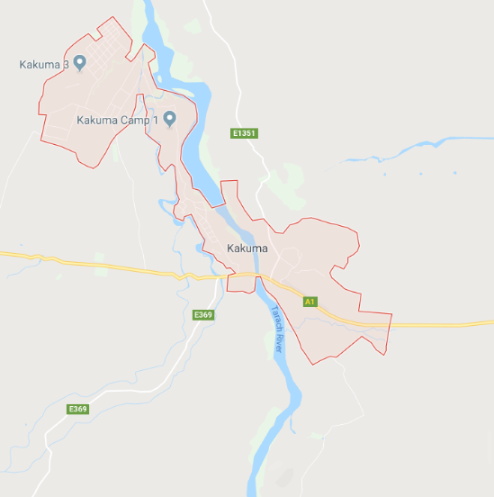
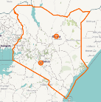
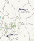
Kakuma Settlement
Kakuma is located in Turkana County, northwestern Kenya
Kakuma hosts one of the longest-lasting refugee settlements in the world. First established in 1992, Kakuma has a large population of long-established refugees from Somalia, Ethiopia, and DRC. Over half of the current population of 185,000, however, are recent arrivals from South Sudan.

Kakuma town, the settlement’s host community, population 60,000, is economically integrated with the refugee settlement. Many in the host community benefit from business and employment opportunities in the settlement, including construction, and firewood and charcoal supply. [1]

This market profile seeks to inform businesses and entrepreneurs of the opportunities and challenges of operating in Kakuma’s host county, Turkana County. The references cited here can serve as resources for further market analysis.

Livelihoods [2]
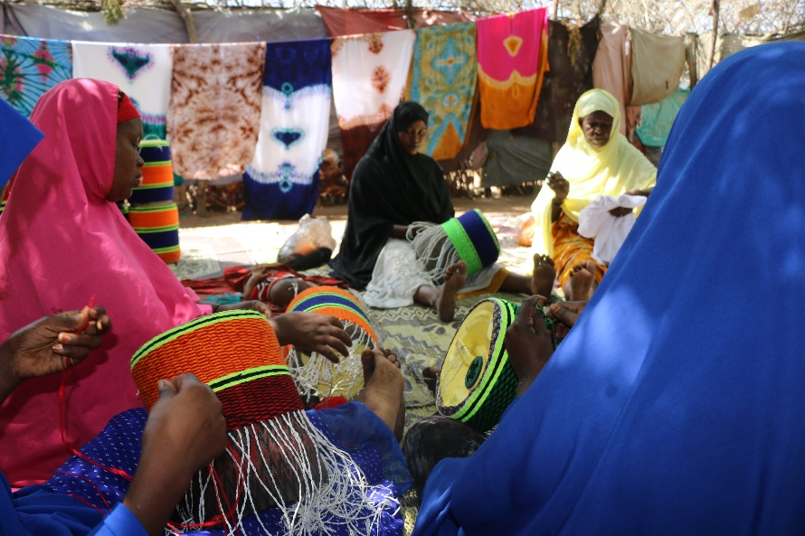  Women manufacture artisanal crafts  (credit: Norwegian Refugee Council) |  | Business activities  - 2,000+ businesses in Kakuma settlement, of which 38% are registered.  - 10 major markets.  - 232 shops in Kakuma town, of which 51% are registered.  - Initial investment in new business averages KES 18,000.  - 7% of host community businesses sell fuelwood or charcoal.  - Equity Bank operates a branch in Kakuma, where refugees may open a bank account with either an Alien ID card, or a registration document from UNHCR.
Employment  Refugee Host  Unemployed 27% 14%  Employed 13% 30%  Business owner 12% 39%  Other 48% 17% | Access to startup capital  Refugee Host  Loans 11% 9%  Personal savings 47% 53%  Friends or family 42% 39%

Income and Expense [2]
Income  - Refugee average income:  KES 5,597 per month  - Host average income:  KES 15,863 per month | Expenditure  - Refugee annual household expenditure per capita:  KES 9,400  - Host annual household expenditure per capita:  KES 60,200
Annual household expenditure for hosts and refugees totals KES 5.8 billion (USD 56.2 million)
Annual household expenditure (KES millions)

Education and Skills [2]
Gender disparity in educational attainment exists for both the refugee and host communities. Men are a third as likely as women to have had no education at all, but are eight times more likely to have completed a university degree, and 3.5 times more likely to have had some vocational training.

Among refugees, education levels vary by nationality. Refugees from Sudan and DRC report greater levels of basic education as compared to those from South Sudan, Rwanda, or Somalia.
Educational attainment of hosts and refugees in Kakuma

Energy [3]
Household energy expenditure (KES) Kakuma I
Lighting devices - share of households in Kakuma I
 | Monthly average | Annual total
Lighting | 372 | 64.2 MM
Phone charging | 35 | 6.1 MM
Cooking | 499 | 86.1 MM
Total | 906 | 156.4 MM

Cook stove use and expenditure in Kakuma I
 | Use | Monthly expense (KES)
3-stone | 27% | 477
Improved - wood fuel | 44% | 203
Improved - charcoal | 23% | 978
Other | 6% | N/A

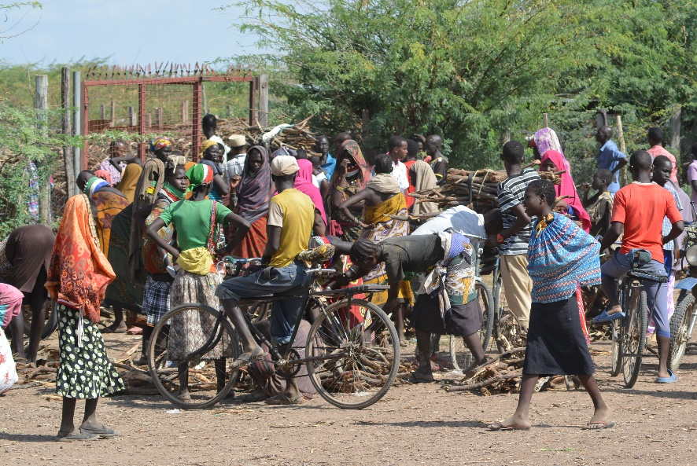  A wood fuel collection point  (credit: Norwegian Refugee Council) | Access to cooking fuel  - Fuel wood distribution in Kakuma is run by LOKADO, a local NGO. LOKADO also engages in clean cook stove distribution and tree planting activities.  Access to power  - Solar lanterns: donated by UHNCR, NGOs  - Stand-alone diesel: USD 1 million per year spent by NGOs  - Independent diesel mini-grids: 1,700 customers

Internet and Mobile [4]
Access to affordable mobile connectivity is a high priority for refugees in Kakuma, and as an immediate need, is rated on par with access to food and water, healthcare or clothing.

Top uses of mobile internet
- Social media
- Looking for information
- Entertainment
- Voice/video communication
- Storing personal information
- Sending/receiving money
- Directions

Top desired mobile services
- Financial, cash transfers
- Education
- Family reunification
- Application status
- Protection services
- Job support
- Health and nutrition
- Identity
- Lodging

Internet and Mobile (con’t)
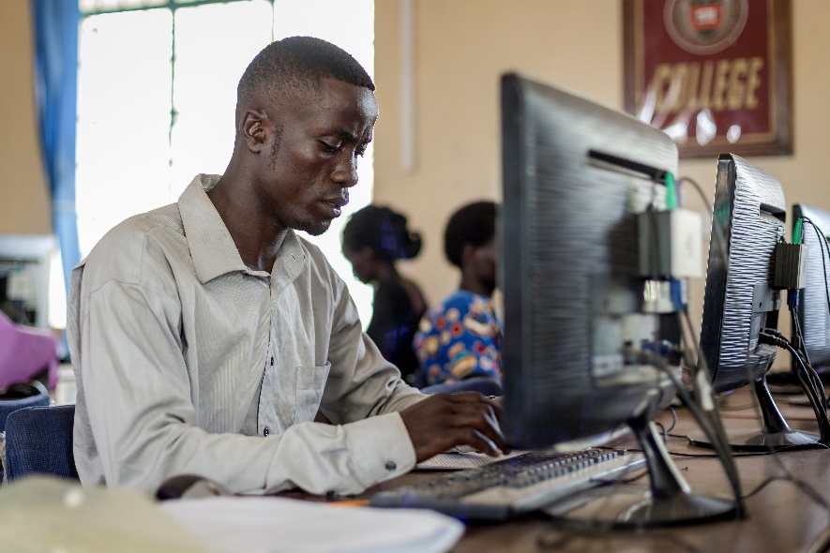  NGOs offer access to online education  (credit: © UNHCR/Antoine Tardy) | NGO connectivity [5]  Perceived quality  - NGOs report quality as ‘Acceptable to Good’  NGO access modes  - Microwave link (Safaricom)  NGO access costs  - Reported to range from $73/Mbps/month to $140/Mbps/month
Refugee connectivity
Survey data on the quality of mobile access in Kakuma settlement [4]

References

[1] | UNHCR, "Yes, In My Back Yard," 2016.
[2] | IFC, "Kakuma as a Marketplace," 2018.
[3] | Moving Energy Initiative, "Prices, Products and Priorities," 2018.
[4] | Humanitarian Innovation Fund, "Innovating mobile solutions for refugees in East Africa," 2018.
[5] | NetHope.

